Lab7: Brandon Kowal, Bernard Owusu Sefah

THERMOSTAT LAB

Abstract

The lab made a Thermostat design. There were 4 inputs with 2 of them for temperature sensors and the other 2 were direct inputs for if the Heat(H) or A/C(A) wanted to be on. The thermostat displays a light when it’s running and displays if the Heat or A/C is on. The 7-segment chip had a lot of direct Vcc inputs so to power source needed to be change to the switches on the breadboard, so every segment could be displayed clearly.

Introduction

This lab is to make a Thermostat that has 4 inputs and 8 outputs. Two of the inputs are for inputting either The Heat or the A/C. The other two are sensors for if the temperature are more than the set temperature the A/C will turn on only if the A/C is set to be on. If the temperature is below the set temperature than the Heater will turn on only if the Heater is set to be on. Those two situations happen a light will turn on. When you set the heater to be on an H will display and a (A) will display when the A/C is set. Those will display on the 7-Segment Display chip.

Methods

1. Developed a simple thermostat circuit using the 7400 IC and the 7-segment display which uses the led lights on the ETS-7000 to tells when the Heat and Ac is on without running and when on and running.
2. Connect each pin to the corresponding ground and Vcc to the ETS-7000 to each IC
3. Connect the 7400 IC to the 7-segment display with the corresponding input and output of the IC.
4. Connect the +5v to both the IC and the 7-segment display and ground the IC and the 7-segment display.
5. Connect a 330 ohms resistor to the display and power on the ETS-7000.

Results

Fig 1 Showing A (AC) and running

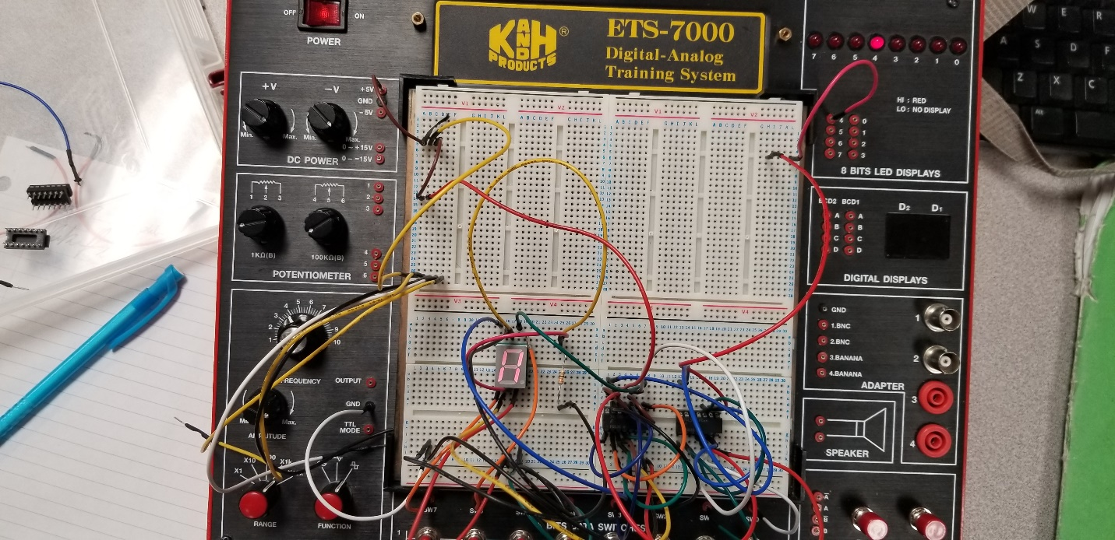

Fig 2 showing A (AC) and not running

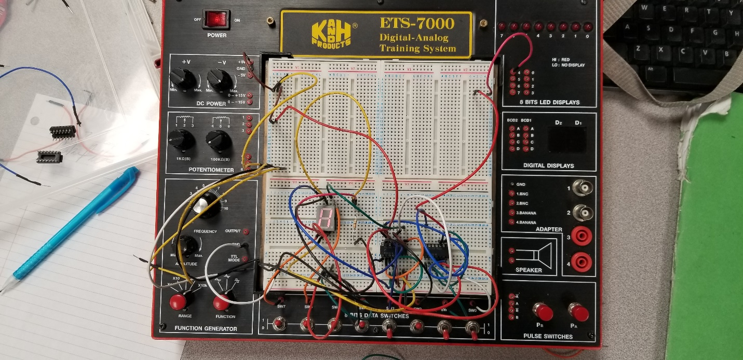

Fig 3 Showing H (Heat) and running

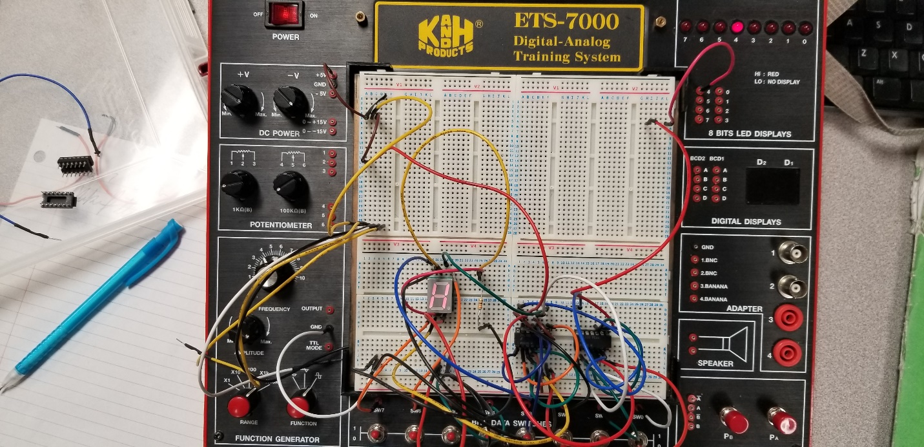

Fig 4 showing H (Heat) and not running

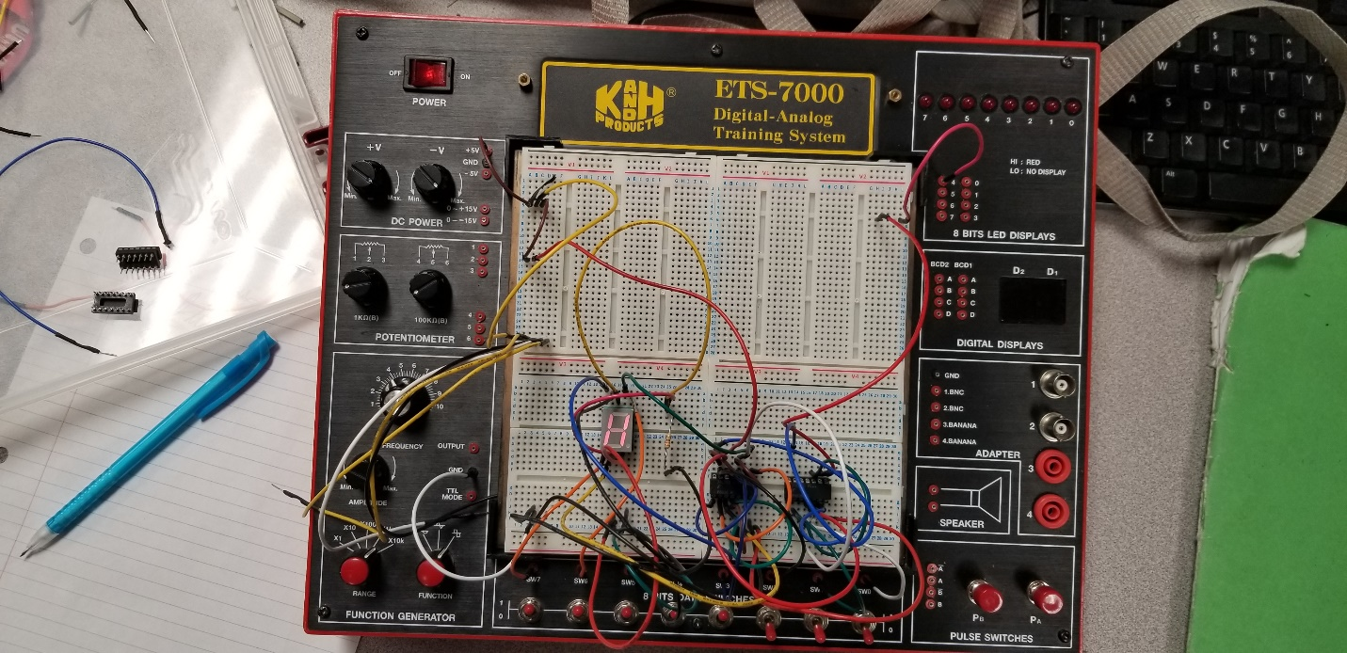

Discussion

In the lab we were able to display the light with no problems. When we added the 7-segment display chip we couldn’t get what we wanted it to display at first. We had to test to see what the problem was, and we found that since we were using the Vcc for a lot of the inputs so there wasn’t enough power to display every segment. So, we took the 4 inputs from the Vcc and put it into other 4 open switches and kept it as a 1 input. Doing it this way gave us the correct display.

Conclusion

So, we were able to display the H and the A with the light displaying. We had minor issues with the Vcc input and all the experiment truth table tests were correct.

Appendix

Lab Attendance: Bernard Owusu Sefah: Yes Brandon Kowal: Yes

Involvement in Lab: Bernard Owusu Sefah: 55 Brandon Kowal: 45

Involvement in Lab Report: Bernard Owusu Sefah: 45 Brandon Kowal: 55